**1. What is CSS ?**

The full form of CSS is Cascading Style Sheets. It is a styling language which is simple enough for HTML elements. It is popular in web designing, and its application is common in XHTML also.

**2. What is the origin of CSS ?**

Standard Generalized Markup Language marked the beginning of style sheets in 1980s.

**3. What are the different variations of CSS ?**

The variations for CSS are:

* CSS 1
* CSS 2
* CSS 2.1
* CSS 3
* CSS 4

**4. What are the limitations of CSS ?**

Limitations are:

* Ascending by selectors is not possible
* Limitations of vertical control
* No expressions
* No column declaration
* Pseudo-class not controlled by dynamic behavior
* Rules, styles, targeting specific text not possible

**5. What are the advantages of CSS ?**

Advantages are:

* Bandwidth
* Site-wide consistency
* Page reformatting
* Accessibility
* Content separated from presentation

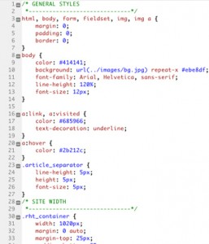

*CSS*

**6. What are CSS frameworks?**

It is a pre-planned libraries, which allows easier and more standards-compliant webpage styling, using CSS language.

**7. How block elements can be centered with CSS1?**

Block level elements can be centered by:

The margin-left and margin-right properties can be set to some explicit value:

|  |  |
| --- | --- |
| 1  2  3  4  5  6  7  8  9  10  11  12  13  14  15  16  17 | BODY {    width: 40em;    background: fluorescent;    }    P {    width: 30em;    margin-right: auto;    margin-left: auto    } |

In this case, the left and right margins will be each, five ems wide since they split up the ten ems left over from (40em-30em). It was unnecessary for setting up an explicit width for the BODY element; it was done here for simplicity.

**8. Who maintains the CSS specifications?**

World Wide Web Consortium maintains the CSS specifications.

**9. In how many ways can a CSS be integrated as a web page?**

CSS can be integrated in three ways:

* Inline: Style attribute can be used to have CSS applied HTML elements.
* Embedded: The Head element can have a Style element within which the code can be placed.
* Linked/ Imported: CSS can be placed in an external file and linked via link element.

**10. What benefits and demerits do External Style Sheets have?**

Benefits:

* One file can be used to control multiple documents having different styles.
* Multiple HTML elements can have many documents, which can have classes.
* To group styles in composite situations, methods as selector and grouping are used.

Demerits:

* Extra download is needed to import documents having style information.
* To render the document, the external style sheet should be loaded.
* Not practical for small style definitions.

**11. Discuss the merits and demerits of Embedded Style Sheets?**

Merits of Embedded Style Sheets:

* Multiple tag types can be created in a single document.
* Styles, in complex situations, can be applied by using Selector and Grouping methods.
* Extra download is unnecessary.

Demerits of Embedded Style Sheets:

* Multiple documents cannot be controlled.

**12. What does CSS selector mean?**

A string equivalent of HTML elements by which declarations or a set of it, is declared and is a link that can be referred for linking HTML and Style sheet is CSS selector.

**13. Enlist the media types CSS allows?**

The design and customization of documents are rendered by media. By applying media control over the external style sheets, they can be retrieved and used by loading it from the network.

**14. Differentiate logical tags from physical tags?**

* While physical tags are also referred to as presentational mark-up, logical tags are useless for appearances.
* Physical tags are newer versions while logical tags are old and concentrate on content.

**15. Differentiate Style Sheet concept from HTML?**

While HTML provides easy structure method, it lacks styling, unlike Style sheets. Moreover, style sheets have better browser capabilities and formatting options.

**16. Describe ‘ruleset’?**

Ruleset : Selectors can be attached to other selectors to be identified by ruleset.

It has two parts:

* Selector, e.g. R and
* declaration {text-indent: 11pt}

**17. Comment on the Case-sensitivity of CSS ?**

Although, there are no case-sensitivity of CSS, nevertheless font families, URL’s of images, etc is. Only when XML declarations along with XHTML DOCTYPE are being used on the page, CSS is case -sensitive.

**18. Define Declaration block?**

A catalog of directions within braces consisting of property, colon and value is called declaration block.

e.g.: [property 1: value 3]

**19. Enlist the various fonts’ attributes?**

They are:

* Font-style
* Font-variant
* Font-weight
* Font-size/line-height
* Font-family
* Caption
* Icon

**20. Why is it easy to insert a file by importing it?**

Importing enables combining external sheets to be inserted in many sheets. Different files and sheets can be used to have different functions. Syntax:

@import notation, used with <Style> tag.

**21. What is the usage of Class selector?**

Selectors that are unique to a specific style, are called CLASS selectors. Declaration of style and association with HTML can be made through this. Syntax:

Classname

it can be A-Z, a-z or digits.

.top {font: 14em ;}, class selector

<Body class= “top”> this class is associated with element </body>

**22. Differentiate Class selector from ID selector?**

While an overall block is given to class selector, ID selector prefers only a single element differing from other elements.

**23. Can more than one declaration be added in CSS?**

Yes, it can be achieved by using a semicolon.

**24. What is Pseudo-elements ?**

Pseudo-elements are used to add special effects to some selectors. CSS in used to apply styles in HTML mark-up. In some cases when extra mark-up or styling is not possible for the document, then there is a feature available in CSS known as pseudo-elements. It will allow extra mark-up to the document without disturbing the actual document.

**25. How to overrule underlining Hyperlinks?**

Control statements and external style sheets are used to overrule underlining Hyperlinks.

E.g.:

|  |  |
| --- | --- |
| 1  2  3  4  5  6  7 | B {    text-decoration: none;    }    <B href="career.html" style="text-decoration: none">link text</B> |

**26. What happens if 100% width is used along with floats all across the page?**

While making the float declaration, 1 pixel is added every time it is used in the form of the border, and even more float is allowed thereafter.

**27. Can default property value be restored through CSS? If yes, how?**

In CSS, you cannot revert back to old values due to lack of default values. The property can be re- declared to get the default property.

**28. Enlist the various Media types used?**

Different media has different properties as they are case insensitive.

They are:

* Aural – for sound synthesizers and speech
* Print – gives a preview of the content when printed
* Projection- projects the CSS on projectors.
* Handheld- uses handheld devices.
* Screen- computers and laptop screens.

**29. What is CSS Box Model and what are its elements?**

This box defines design and layout of elements of CSS. The elements are:

**Margin**: the top most layer, the overall structure is shown

**Border**: the padding and content option with a border around it is shown. Background color affects the border.

**Padding**: Space is shown. Background colour affects the border.

**Content**: Actual content is shown.

**30. What is contextual selector?**

Selector used to select special occurrences of an element is called contextual selector. A space separates the individual selectors. Only the last element of the pattern is addressed in this kind of selector. For e.g.: TD P TEXT {color: blue}

**31. Compare RGB values with Hexadecimal color codes ?**

A color can be specified in two ways:

* A color is represented by 6 characters i.e. hexadecimal color coding. It is a combination of numbers and letters and is preceded by #. e.g.: g {color: #00cjfi}
* A color is represented by a mixture of red, green and blue. The value of a color can also be specified. e.g.: rgb(r,g,b): In this type the values can be in between the integers 0 and 255. rgb(r%,g%,b%): red, green and blue percentage is shown.

**32. Define Image sprites with context to CSS ?**

When a set of images is collaborated into one image, it is known as ‘Image Sprites’. As the loading every image on a webpage consumes time, using image sprites lessens the time taken and gives information quickly.

CSS coding:

|  |  |
| --- | --- |
| 1 | img.add { width: 60px; height: 55px; background: url (image.god) 0 0; } |

In this case, only the part needed is used. The user can save substantial margin and time through this.

**33. Compare Grouping and Nesting in CSS ?**

Grouping: Selectors can be grouped having the same values of property and the code be reduced.

E.g. :

|  |  |
| --- | --- |
| 1  2  3  4  5  6  7  8  9  10  11  12  13  14  15  16  17 | h1 {    color: blue;    }    h2 {    color: blue;    }    p {    color: blue;    } |

It can be seen from the code that every element shares the same property. Rewriting can be avoided by writing each selector separated by a comma.

Nesting: Specifying a selector within a selector is called nesting.

|  |  |
| --- | --- |
| 1  2  3  4  5  6  7  8  9  10  11  12  13  14  15  16  17  18  19  20  21  22  23  24  25 | P    {    color: red;    text-align: left;    }    .marked    {    background-color: blue;    }    .marked p    {    color: green;    } |

**34. How can the dimension be defined of an element ?**

Dimension properties can be defined by:

* Height
* Max-height
* Max-width
* Min-height
* Min-width
* Width

**35. Define float property of CSS?**

By float property, the image can be moved to the right or the left along with the text to be wrapped around it. Elements before this property is applied do not change their properties.

**36. How does Z index function?**

Overlapping may occur while using CSS for positioning HTML elements. Z index helps in specifying the overlapping element. It is a number which can be positive or negative, the default value being zero.

**37. What is graceful degradation?**

In case the component fails, it will continue to work properly in the presence of a graceful degradation. The latest browser application is used when a webpage is designed. As it is not available to everyone, there is a basic functionality, which enables its use to a wider audience. In case the image is unavailable for viewing, text is shown with the alt tag.

**38. What is progressive enhancement?**

It’s an alternative to graceful degradation, which concentrates on the matter of the web. The functionality is same, but it provides an extra edge to users having the latest bandwidth. It has been into prominent use recently with mobile internet connections expanding their base.

**39. How can backward compatibility be designed in CSS?**

HTML sheet methods is collaborated with CSS and used accordingly.

**40. How can the gap under the image be removed?**

As images being inline elements are treated same as texts, so there is a gap left, which can be removed by:

CSS

|  |  |
| --- | --- |
| 1 | img { display: block ; } |

**41. Why is @import only at the top?**

@import is preferred only at the top, to avoid any overriding rules. Generally, ranking order is followed in most programming languages such as Java, Modula, etc. In C, the # is a prominent example of a @import being at the top.

**42. Which among the following is more precedent: CSS properties or HTML procedures?**

CSS is more precedent over HTML procedures. Browsers, which do not have CSS support, display HTML attributes.

**43. What is Inline style?**

The Inline style in a CSS is used to add up styling to individual HTML elements.

**44. How comments can be added in CSS?**

The comments in CSS can be added with /* and */.

**45. Define Attribute Selector ?**

It is defined by a set of elements, value and its parts.

**46. Define property?**

A style, that helps in influencing CSS. E.g. FONT. They have corresponding values or properties within them, like FONT has different style like bold, italic etc.

**47. What is Alternate Style Sheet?**

Alternate Style Sheets allows the user to select the style in which the page is displayed using the view>page style menu. Through Alternate Style Sheet, user can see a multiple version of the page on their needs and preferences.

**48. Are quotes mandatory in URL’s?**

Quotes are optional in URL’s, and it can be single or double.

**49. What is at-rule?**

Rule, which is applicable in the entire sheet and not partly, is known as at-rule. It is preceded by @ followed by A-Z, a-z or 0-9.

**50. How can CSS be cascaded to mix with user’s personal sheet?**

Properties can be a set in recommended places and the document modified for CSS to mix with user’s personal sheet.

## **Explain what a class selector is and how it’s used:**

* + A class can be thought of as a grouped collection of CSS attributes applied to HTML elements. This allows you to apply the same styling to multiple HTML elements by placing them in the same CSS class.
  + Class methods can be called by inserting a ‘class’ property and name within an HTML element, then calling the class name with a ‘.’ in the CSS doc.
  + Class syntax:

**Within an HTML doc:**

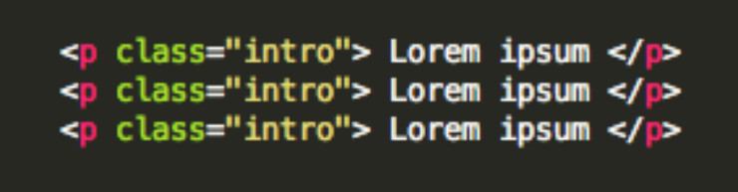

**Within a CSS doc:**

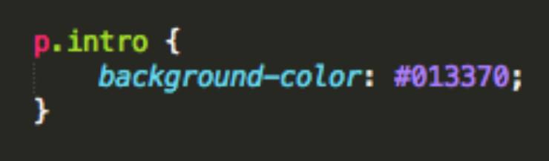

* + The code listed here identifies the class ‘intro’ in the HTML doc, then applies the same background-color styling to all paragraphs within that class.

## **What are pseudo classes and what are they used for?**

* + Pseudo classes are similar to classes, but are not explicitly defined in the markup, and are used to add additional effects to selected HTML elements such as link colors, hover actions, etc.
  + Pseudo classes are defined by first listing the selector, followed by a colon and then pseudo-class element. E.g., a:link{ color: blue }, or a:visited { color: red }
  + Pseudo-class syntax:

selector:pseudo-class {

property:value;}

* + Syntax for using a pseudo class within a CSS class:

selector.class:pseudo-class {

property:value;}

* + :link, :visited, :hover, :active, :first_line are all examples of pseudo classes, used to call a specific action on an element, such as the changing of a link color after it has been visited.

## **Explain the three main ways to apply CSS styles to a Web page:**

* + **Inline:** Though this method often goes against best practices, it’s easily done by inserting a ‘style’ attribute inside an HTML element:
    - e.g.) <p style=”color:blue”>Lorem Ipsum</p>
  + **Embedded/Internal:** Done by defining the head of an HTML document by wrapping characteristics in a <style> tag.

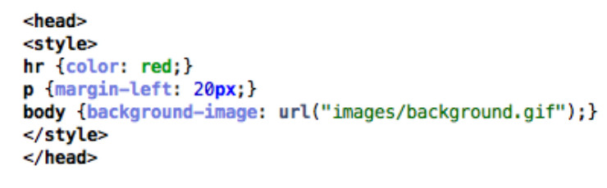

* + **Linked/External:** CSS is placed in an external .css file, and linked to the HTML document with a <link> tag. This can also be accomplished using the ‘@import’, however, this can slow page load time and is generally not advised.

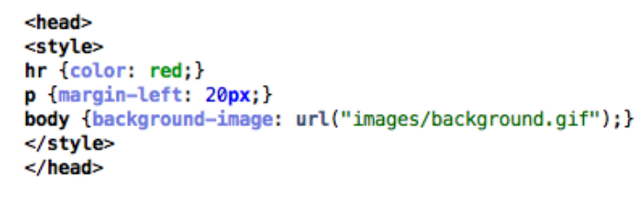

## **What is grouping and what is it used for?**

* + Grouping allows you to apply the same style to multiple elements with a single declaration. This is done by grouping the selectors into a list, separated by commas.

e.g.) h1, h2 { font-family: Helvetica; font-size: 20; }

* + Grouping helps memory usage and enhances readability.

## **What is an ID selector and how is it used?**

* + IDs are used to identify and apply styling to a single specific HTML element. IDs are defined within the HTML page by inserting an ID selector in the HTML element:
    - eg)

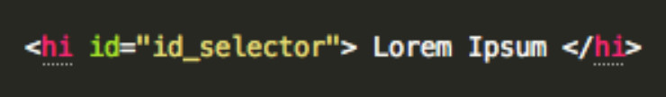

* + ID selectors are defined within the CSS page by calling a ‘#’ followed by the name of the ID:
    - eg)

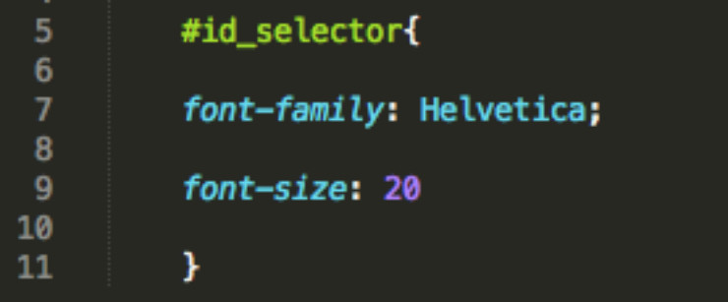

* + ID selectors are unique and can only be applied to a single element.

## **What is a Class selector and how does it differ from an ID selector?**

* + Class selectors are used to apply style to multiple HTML identified with the same class.
  + Within the HTML doc:
  + e.g.)

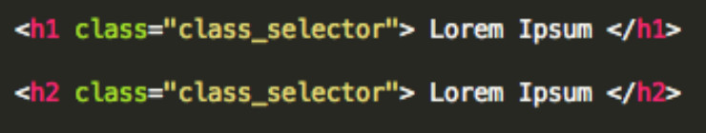

* + Class selectors are called within the CSS document by a ‘.’, followed by the class name:
  + Within the CSS doc:
    - e.g.)

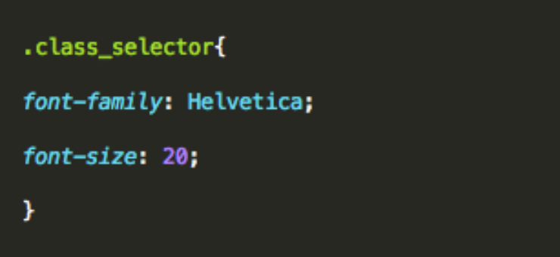

* + The main difference is that the same class selector can be applied to multiple HTML elements, whereas ID selectors are unique..

## **What are child selectors?**

* + Child selectors are another way to group and style a set of elements that descend from a parent element.
  + A child selector is matched by calling two or more elements, separated by a ‘>’ sign to indicate inheritance.

e.g.)

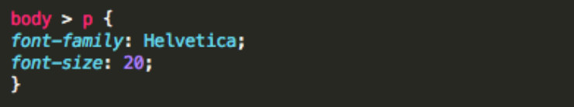

* + In this example, the same styling would be applied to all paragraphs within the body.

## **What are the different CSS properties used to change dimensions and what values can they accept?**

* + height: Sets a specific height
    - auto
    - length
    - *%*
    - inherit
  + width: Sets a specific width
    - auto
    - length
    - *%*
    - inherit
  + max-height: Sets a maximum height
    - auto
    - length
    - *%*
    - inherit
  + max-width: Sets a maximum width
    - auto
    - length
    - *%*
    - inherit
  + min-height: Sets a minimum height
    - auto
    - length
    - *%*
    - inherit
  + min-width: Sets a minimum width
    - auto
    - length
    - *%*
    - inherit

## **How is the float property implemented in CSS?**

* + Floats allow an element to be positioned horizontally, allowing elements below the floated element to flow around it. Several floating elements can be placed together to make a gallery type layout.
  + Floats can only accept a left or right value.
  + e.g.)

img {

float: right;

width: 50px;

margin: 5px;

}

* + To prevent subsequent elements from flowing around the floated element, pass in the clear property, followed by the side you wish to disable (i.e., ‘left’, ‘right’, ‘both’).

## **What is the CSS Box Model used for? What are the elements that it includes?**

* + CSS box model is made up of margins, borders, padding, and content.
  + Box model provides a structured way to space elements in relationship to each other.

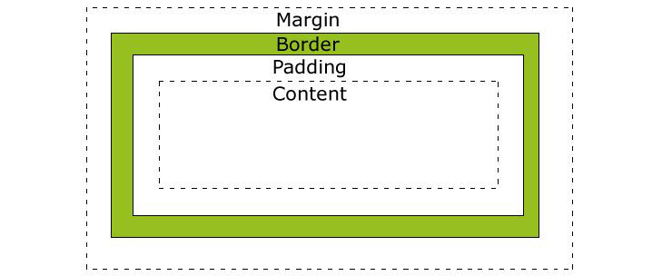

[W3schools](http://w3schools.com/)

## **How to restore the default property value using CSS?**

* + In short, there’s no easy way to restore to default values to whatever a browser uses . The closest option is to use the ‘initial’ property value, which will restore it to the default CSS values, rather than the browser’s default styles.

## **What is the purpose of pseudo-elements and how are they made?**

* + Pseudo elements are made using a double colon (::) followed by the name of the pseudo element.
  + Pseudo-elements are used to add special effects to some selectors, and can only be applied to block-level elements.
  + Most commonly used pseudo-elements are ::first_line, ::first_letter, ::before, ::after

## **How are inline and block elements different from each other?**

* + A block element is an element that takes up the full width available, and has a line break before and after it. <h1>, <p>, <li>, and <div> are all examples of block elements.
  + An inline element only takes up as much width as necessary, cannot accept width and height values, and does not force line breaks. <a> and <span> are examples of inline elements.

## **What is the purpose of the z-index and how is it used?**

* + The z-index helps specify the stack order of positioned elements that may overlap one another. The z-index default value is zero, and can take on either a positive or negative number.
  + An element with a higher z-index is always stacked above one with a lower index.
  + Z-Index can take the following values:

**Auto:** Sets the stack order equal to its parents.

**Number**: Orders the stack order.

**Initial:** Sets this property to its default value (0).

**Inherit:** Inherits this property from its parent element.

## **What are the advantages and disadvantages of External Style Sheets?**

* + The biggest advantages of external style sheets are that they can be applied to multiple documents while being managed from a single style sheet. This keeps code DRY and improves efficiency and convenience.
  + The disadvantages are that it may decrease loading time in some situations. It may also not be practical if there are not enough styling conditions to justify an external sheet.

## **List the main CSS style sheet properties:**

* + Background
  + Text
  + Font
  + Border
  + Outline
  + Margin
  + Padding
  + List
  + Table

## **Which online resources do you refer to when having issues with CSS?**

* + No real correct answer here, save for being able to discuss your favorite online CSS community forums and resources. e.g. Mozilla Developer Network, StackOverflow, etc.
  + This is just your opportunity to discuss larger CSS issues and show how plugged-in you are to the community.

## **What are the various techniques for clearing floats?**

* + At some point or another, you will likely experience a collapsed float, which you will need to address.
  + This can be accomplished several ways, including using a clearfix[2](http://www.skilledup.com/articles/25-css-interview-questions-answers#footnote_1_20196), by floating the parent element of the collapsed element, or by using an overflow property[3](http://www.skilledup.com/articles/25-css-interview-questions-answers#footnote_2_20196).

## **Explain the difference between visibility:hidden and display:none**

* + visibility:hidden simply hides the element, while it will still take up space and affect the layout of the document.
  + display:none also hides the element, but will not take up space and the page will appear as if the element is not present.

## **What are some of the new features and properties in CSS3?**

* + Box model
  + New Web fonts
  + Rounded corners
  + Border Images
  + Box Shadows, Text Shadows
  + New Color schemes (RGBA)
  + Transform property
  + New Pseudo-classes
  + Multi-column layout
  + New Gradients

## **Why shouldn’t I use fixed sized fonts ?**

* + Often times, fixed font sizes will show up incorrectly on the user end and will prohibit responsiveness. Using relative sizing will keep fonts proportionate in their relationships to each other and will allow for greater end user flexibility.

## **Which font names are available on all platforms ?**

* + Only five basic font families( serif, sans-serif, cursive, fantasy, and monsospace) are recognized across platforms, rather than specific fonts.
  + Specific font name recognitions will vary by browser.

## **Do you use grid systems, and if so, what do you prefer?**

* + Again, no correct answer here. Just be able to discuss the pros and cons of different grid systems, mobile-first, fluid and responsive web design issues.

## **What are the advantages/disadvantages of using CSS preprocessors? (SASS, Compass, Stylus, LESS)**

* + Here is another opportunity to discuss your personal preferences on use of CSS preprocessors and why.
  + While there’s no right or wrong answer here, below are some commonly cited pros and cons of using preprocessors:

**Benefits:** Ability to use nested sytax, define variables and mixins, use of mathematical and operational functions, and the ability to join multiple files into a single one.

**Disadvantages:** Difficulties tracking file size, maintenance and updating issues, difficulties debugging.

## **Why and how are shorthand properties used? Give examples.**

* + Using shorthand properties can improve page load times and reduce file size.
  + Can be done with background, font, border, padding, outline, and list-style properties.
  + Shorthanding is accomplished by listing the property values on a single line, in a specific order.

e.g.) Code snippet ‘a’ gets shorthanded into code snippet ‘b’ by condensing the property values (in order) onto a single line:

**a)**

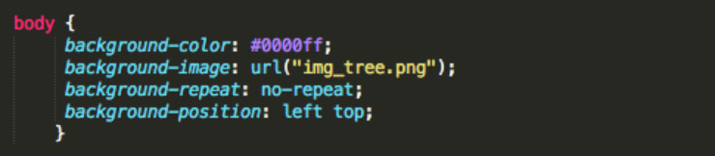

**b)**

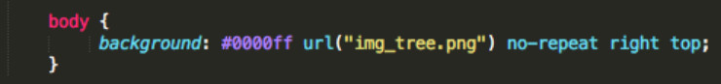

## **Effectively Communicating Your Skills**

While it’s true there’s no substitute for a strong portfolio and raw coding skills, being able to discuss CSS principles and concepts in a clear and coherent manner will demonstrate your communication skills as well as your theoretical and peripheral subject knowledge. This can be particularly handy when being interviewed by a non-technical person, as being able to describe complex issues in plain language will help you stand out. While you’ll still need to be a strong and competent programmer to get the job, taking the time to prep for the verbal interview is still necessary. If you’re strong and up to date on CSS, these questions should be a breeze. If not, use the questions to help sort out where your weaknesses are and brush up with an online course.